**Basic git commands**

**1.git config**

This command sets the author name and email address respectively to be used with your commits.

Usage: git config –global user.name “[name]”

Usage: git config –global user.email “[email address]”

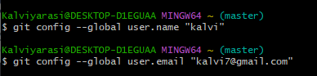

**2.git init**

This command is used to start a new repository

Usage: git init [repository name]



3.git add

Usage: git add [file]

This command adds a file to the staging area.

4.git clone

Usage: git clone [url]

This command is used to obtain a repository from an existing URL.

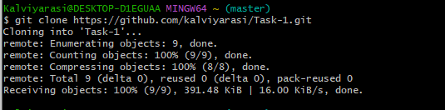

5.